EXPERIMENT-5
5. A warehouse robot chooses the nearest storage rack at every step to minimize
travel time. Implement Greedy Best First Search Algorithm. Solve pathfinding using greedy heuristics.

PROGRAM:
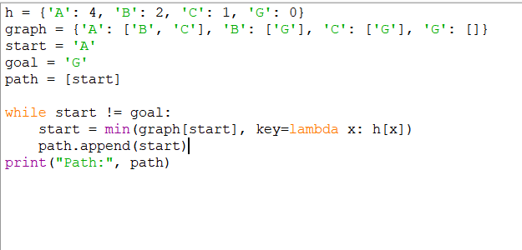

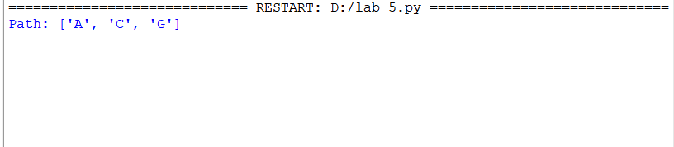
OUTPUT:

